Photos from the plaster and splints laboratory at the college, including images of the workshop and rooms, with students working

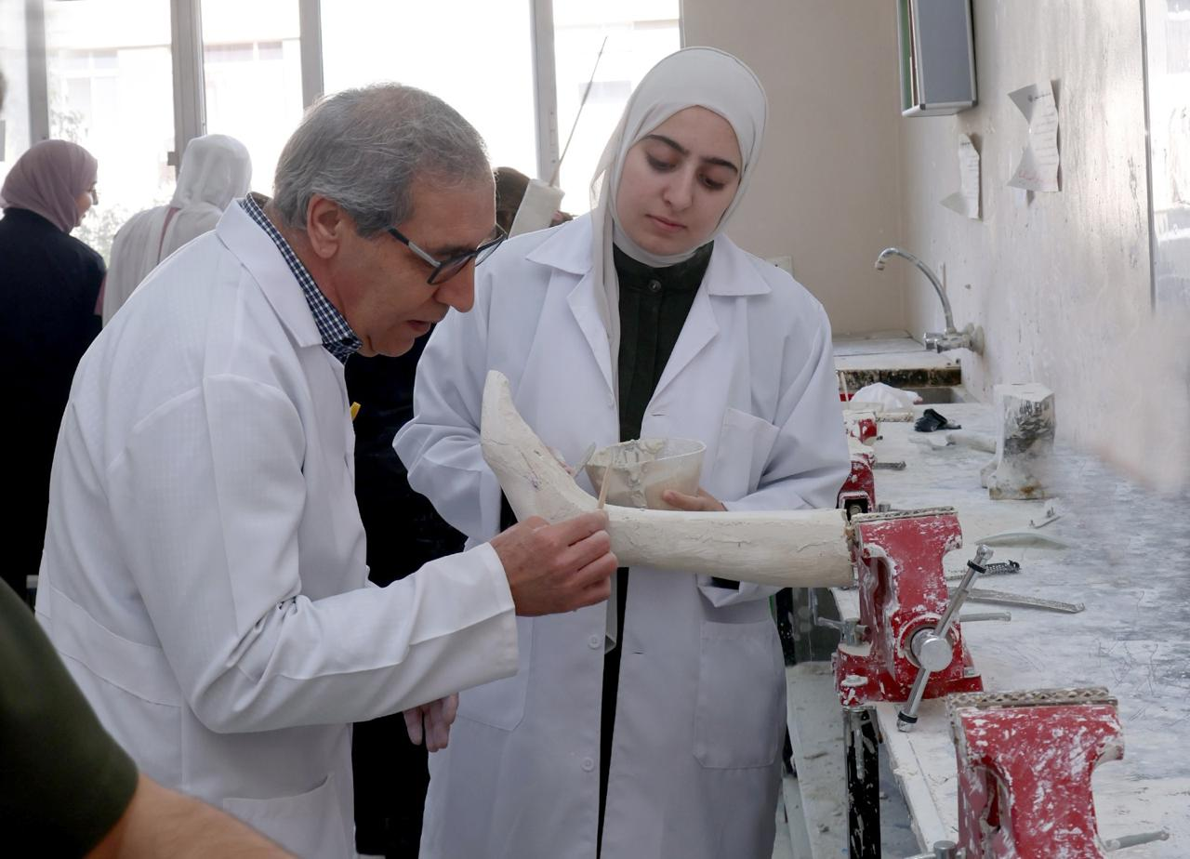

This is a picture from the lower extremity assistive devices laboratory, where Mr. Houshing is providing practical guidance to a student while working on molding and adjusting a plaster cast for the foot.

. 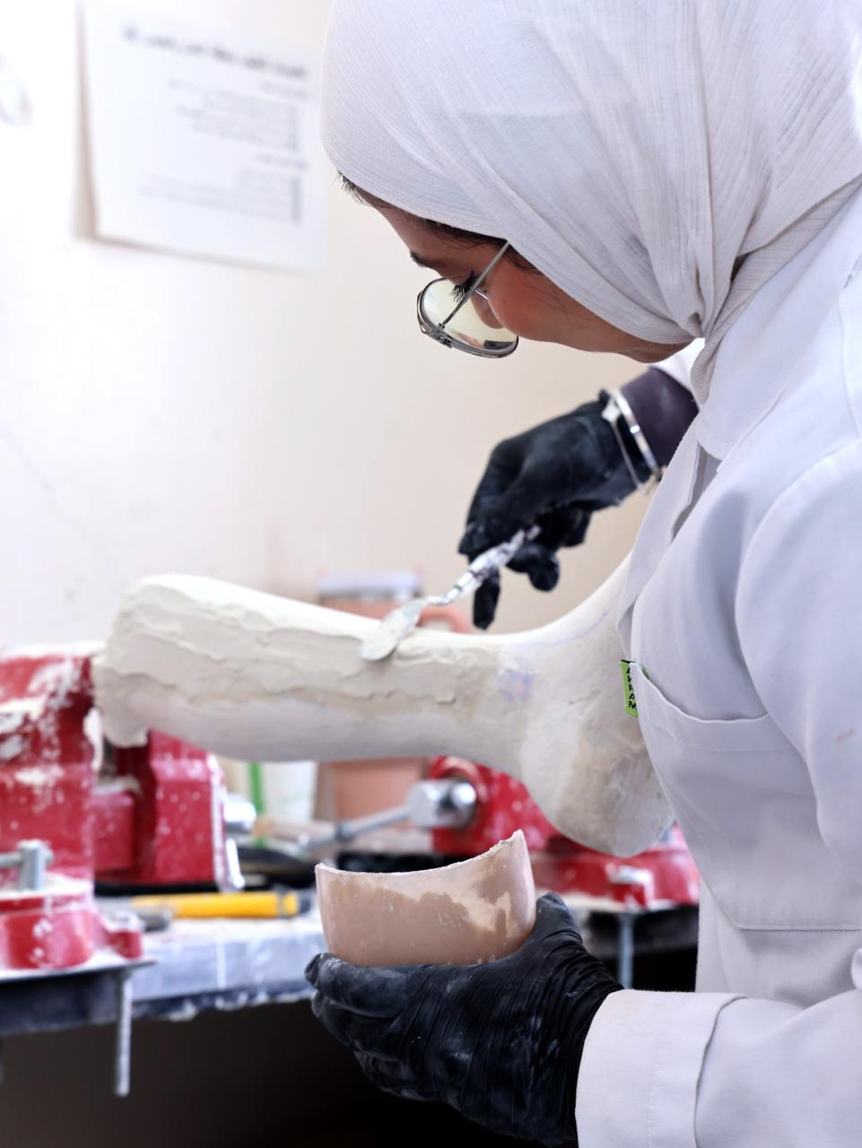

A student is working on carving and adjusting the plaster cast with precision as part of the practical training for preparing lower extremity assistive devices."
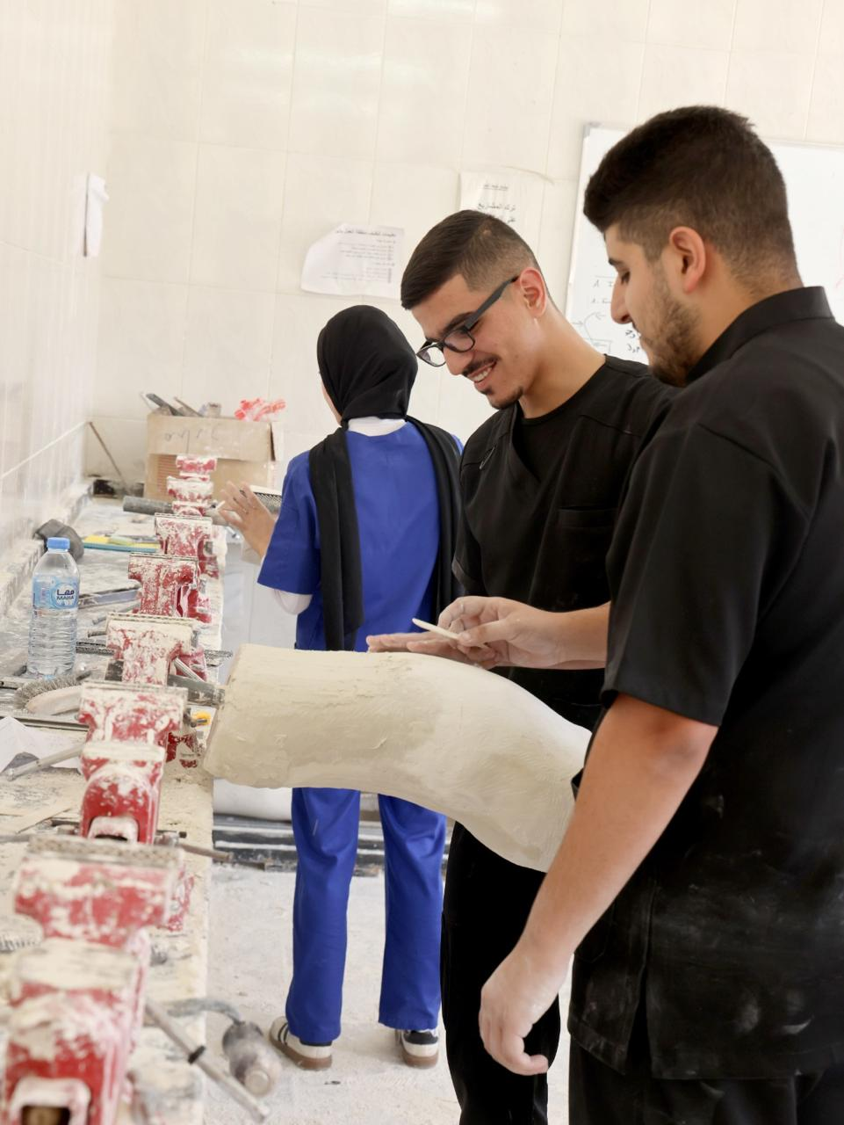

This is a picture from the spinal orthotics laboratory, where students are shaping and smoothing plaster casts as part of the practical training for preparing orthotic devices.

